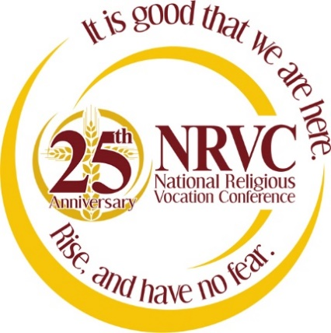
Thank You! Gracias! Grazie! Merci! Danke! Dziękuję! Cảm ơn bạn!

The National Religious Vocation Conference (NRVC) extends its heartfelt gratitude
to our many sponsors who have generously supported this Convocation.

Christian Brothers Services
for the sponsorship of keynote speaker Father Bernhard Eckerstorfer, O.S.B.

Dominican Sisters of Peace
for its contribution to Sunday’s coffee and tea break.

Guest House
for sponsoring the following two workshops:
Discernment and Male Spirituality and Self-care: Achieving Balance and Avoiding Burnout.

J.S. Paluch Company and World Library Publications
for sponsoring Friday evening’s concert.

Paluch Family Foundation
for its contribution to the Opening Reception.

Praesidium, Inc.
for its contribution to presenter Dr. Mary Gautier and our panel presenters.

Presence Health
for the sponsorship of keynote speakers
Sister Theresa Rickard, O.P. and Sister Colleen Mary Mallon, O.P.

Saint John Vianney Center
for its contribution to Sunday’s coffee and tea break.

Sisters of St. Francis of the Immaculate Conception
for providing our Convocation centerpieces.

Society of Mary (Marianists)
for our Thursday and Friday coffee and tea breaks.

TrueQuest Communications
for its contribution to the Opening Reception.

A special thank you to the members of NRVC Region 7 for their generous support, time,
and efforts in making this 2014 Convocation a success!

