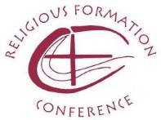

The Religious Formation Conference (RFC) is seeking a full time Program Director, who will work collaboratively with the Conference’s national office staff, advisory and program teams, and others to develop, design, market, coordinate, and implement programs for women and men religious engaged in the ministry of formation as well as programs for newer members in initial formation and for the lifelong formation of seasoned members.
The Conference has recently relocated to Catholic Theological Union in Chicago, a site rich in possibilities for collaboration with others committed to the flourishing of religious life.
Qualifications include a Master’s level in theology or an equivalent credential. The successful candidate will have experience in initial or lifelong formation ministry and/or faith formation as well as in program design implementation, and evaluation and some proficiency in technology, in particular with its use in instruction and training.
Please see www.relforcon.org for more detailed information.
To apply, please submit cover letter, resume, and three reference letters to Sister Ellen Dauwer, SC, Executive Director, at rfc@relforcon.org. Applications will be accepted until the position is filled, but preference will be given to applications received by October 17, 2016.

